# *SPANDANA-21*

# *eRule Book*

## Event Name – Pot Painting

## 

**General Rules:**

1. This is a solo event, only 1 participant is allowed per team
2. All the materials like Enamel Paints (different colors), Brush, and Container etc. It should be brought by the participant.
3. Plain brown, grey and white colored pot to be used.
4. Maximum height of the pot 10 inches.
5. Earthen or clay pots to be used.
6. The decision of judges will be final and binding.
7. The criteria for judging will be: choice of design, color combination and cleanliness

**Event Coordinators:**

**Faculty Coordinators:**

1. Dr. Mule Laxmi Devi Ramanaiah, EEE , Ph No: 8328578364
2. Ms. K Harshini, EEE , Ph No: 7702308093

**Student Coordinators:**

1. Mr. P Sai Kishore, EEE- III Year , Ph No: 7032578309
2. Ms. E Srujana, EEE-III Year , Ph No: 7893922481
3. Ms. K Pravalika, EEE-III Year , Ph No: 6304650766
4. Ms. V Vinaya, EEE-I Year , Ph No: 7306464583

## Event Name – Drawing / Painting

## 

**Rules**

1. The drawings should be made on an art paper or an ordinary paper as per the convenience of the participant. There is no restriction for usage of colors.
2. All artwork must be original and pertain to the theme “***Direct observations/portfolio, Self-portrait,current affairs,Thought provoking drawing,seasonal drawing***,”
3. Artwork can be landscape, portraits, still life, abstract, etc.
4. Media allowed includes: Pen, pencil, markers, paints, oils, charcoal, watercolors, canvas, and paper.
5. Any mechanically or electronically generated artwork is not eligible and will be disqualified.
6. The final evaluation of the artworks will be handled by the online **drawing competition** judges. The judges decision is final, and no questions or appeals regarding the painting participant’s outcome will be considered.
7. The criteria for judging will be: Theme of design, Creativity, Engaging, Perfection and Presentation.

**Event Coordinators:**

**Faculty Coordinators:**

1. Ms. D Anitha, AE , Ph No: 7569615133
2. Mr. V Phaninder Reddy, AE, Ph No: 9391027091

**Student Coordinators:**

1. Mr. K Ajay Kumar, AE - II Year , Ph No: 6301864794
2. Ms. Madhunisha, AE -III Year , Ph No: 9390653035
3. Mr. Jadhav Rohith, AE -II Year , Ph No: 91822 69944
4. Ms. Sanjana, AE-I Year , Ph No: 9949235732

## Event Name – Nail Art

## nail-art-designs-for-girls

### General Rules:

The following Rules and regulations apply to all categories and must be carefully read and adhered to. Any Rules and Regulations that are not adhered to will mean immediate disqualification, no exceptions will be made.

1. The video should be 5- 10 minutes long it is in one shot and the camera should not move.
2. The video should be recorded and sent in landscape (horizontal) mode.
3. Participants have to check the video quality of their videos.
4. Participants must not have damaged nails or nails with any infections.
5. Participants have to complete the task within the given time.
6. Further edits or resubmissions will not be entertained.

#### Participants will be judged on the following criteria:

1. Color management
2. Design Control
3. Design Continuity
4. Design quality
5. Originality and Creativity
6. Composition of Design
7. Overall Impression & presentation – Theme
8. Finished quality & Neatness

**Event Coordinators:**

**Faculty Coordinator:**

1. Dr. T Varalaxmi, MBA , Ph No: 8639418996

**Student Coordinator:**

1. Mr. K Suman, MBA- I Year , Ph No: 7075885119

## Event Name – Magical Mehandi

Mehandi is a reflection of the rich Indian culture, bringing together the knowledge of medicinal herbs with many lovely sentiments and beliefs. The result is a ceremony filled with fun and joy and the perfect precursor to the auspicious wedding day. Vedic customs are centered on the idea of “awakening the inner light”. Traditional Indian designs are representations of the sun on the palm, which, in this context, is intended to represent the hands and feet.

## C:\Users\admin\AppData\Local\Microsoft\Windows\INetCache\Content.Word\8ea6452fcb85afd05284589f288fef14.jpg

### Rules:

1. Participants can apply mehandi on their own hand or any other person's hand.
2. The video should be 20- 30 minutes long it is in one shot and the camera should not move.
3. Mehandi design should be creative and unique.
4. Edited photos in any way are not eligible.
5. Mehandi tattoo designs that mimic tattoo (stickers) are not eligible for entry.
6. Participants can use only normal type of mehandi (no extra colours).
7. Neatness will be observed in design.

**Event Coordinators:**

**Faculty Coordinator:**

1. Ms. K L Revathi, MBA , Ph No: 9550041819

**Student Coordinator:**

1. Ms. N Jyosthna, MBA- II Year , Ph No: 832815025

## Event Name –Rangoli

Rangoli is an Indian traditional - folk art, generally created on a floor on special festive occasions. The origin of this art can be traced to the “PURANAS” (works on Hindu mythology). The tradition of Rangoli originated in Maharashtra state and slowly disseminated to other parts of India.

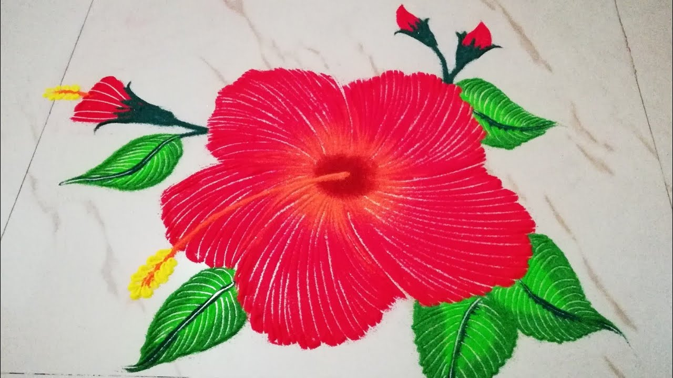

**Rules:**

1. Rangoli art should be of 3 ft x 3 ft.
2. There will be only one round of competition.
3. Surface should be maintained clean.
4. The video should be 10- 30 minutes long it is in one shot and the camera should not move.
5. Edited photos in any way are not eligible.
6. Participants can use Poster Colours or Flower Petals or Saw - Dust or Pulse or Rice.
7. Rangoli has to be hand drawn only.
8. Maximum One (01) participant is allowed in this event.
9. Please bear in mind that your Rangoli art should not offend any viewers.

**Event Coordinators:**

**Faculty Coordinator:**

1. Ms. K L Revathi, MBA , Ph No: 9550041819

**Student Coordinator:**

1. Ms S Deepthi, MBA- II Year , Ph No: 9059407918

## Event Name - Mono Acting



**General Rules:**

1. Late video submissions will not be accepted.
2. All specific and technical rules must be followed.
3. All content submissions – shall be in good taste and shall NOT be obscene, vulgar, libelous, defamatory, immoral, insensitive, insulting, annoying, hurt any religious sentiments, or infringe the rights of any third party, etc.
4. The decisions of the College and judges for any of the Competitions are final and binding.

**Specific Rules:**

1. The acting submission should be a minimum of 90 seconds and a maximum of 180 seconds
2. Participants will have to choose a monologue, a famous speech, or a popular movie scene.
3. The participants must introduce the artist, the character, and the movie from where they have picked up the monologue.
4. Languages: Hindi or English
5. Editing the video in any manner will lead to disqualification.
6. Participants can use costumes while delivering their monologue.

**Technical Guidelines:**

1. Frame yourself such that your facial expressions are clear, and your body movements are captured fully.
2. Ensure that the lighting is good, darkened silhouette video will lead to disqualification.
3. Background noise must be removed.
4. The video must be shot horizontally.
5. The duration of the video has to be between 4-5 minutes.

**Event Coordinators:**

**Faculty Coordinators:**

1. Mr. Ch Suresh Kumar Raju, IT , Ph No: 8121285286
2. Ms. B Pravallika, IT , Ph No: 8187898792

**Student Coordinators:**

1. Mr. B Kamal , IT- III Year , Ph No: 7330781345
2. Mr. T Sathwik, IT-II Year , Ph No: 6303319660
3. Ms. Y Sharmista Reddy, IT-II Year , Ph No: 9052555961

## Event Name – Vegetable Carving

As entertaining fun filled and creative activity that shall help students in enhancing their skills. Fruits and vegetables carving competition shall improve student creativity by giving free expression to the imagination. The activity aims at bringing elegance to the table by combining beauty, finesse and taste.

## funny fruit and vegetable carving (12)

**Rules**

1. Participates must use any fruit or vegetable item that is available for carving.
2. No pre preparation fruits or vegetable can be used in competition is allowed.
3. No mark or drawings should visible on fruit or vegetable.
4. Student must record the activity with mobile phone.
5. Total time 30 minutes is allowed.
6. Only participant should complete entire the carving process.
7. Activity should be held in room or venue which sound proof or without any disturbance.
8. Participant should announce first about the work he is doing and should start immediately after announcement.
9. Evaluation criteria: assessment will be made on skill and time availability.

**Event Coordinators:**

**Faculty Coordinators:**

1. Mr. N Chaitanya Kumar, ME , Ph No: 8008880859
2. Mr. G Sarath Raju, ME , Ph No: 9985820122

**Student Coordinators:**

1. Mr. Sharath, ME- III Year , Ph No: 8374692343
2. Mr. Laxmi Kanth, ME-III Year , Ph No: 9542797220

## Event Name – Dancing (Solo)

## Solo Dance Clip Art - Royalty Free - GoGraph

### GENERAL RULES:

1. The participants must register as individuals only

2. The participants must adhere to the time limit (2-3 minutes) that has been given or else there will be negative marking.

3. Costumes and music tracks must be approved by the Organizing Committee, one week prior to the event.

4. Props must be approved by the Organizing Committee before video submission.

5. Use of fire, water, or sharp objects is not allowed.

6. The participants must submit their final tracks to the Organizing Committee at least two days prior to the event.

7. Late entries will not be accepted.

8. These videos submitted must be submitted to Feelthebeat.spandana2021@gmail.com in MP4 format. The name of the file should be in the following format Participant name Phone number.

9. Dance performance should be in one shot and the camera should not move.

10. No transitions and light effects allowed.

11. Participants are allowed to edit the tracks they use.

12. Music/ Artist credits must be given at the end of the video.

13. Obscenity and vulgarity of any form will lead to immediate disqualification.

14. The decision of the judges will be final and binding on all

**Event Coordinators:**

**Faculty Coordinators:**

1. Ms. P Shalini, CSE , Ph No: 9000996255
2. Ms. B Anupama, CSE, Ph No: 8106557572

**Student Coordinators:**

1. Ms. Raagasree, CSE- III Year , Ph No: 6304395902
2. Ms. Asha Jasmine, CSE -III Year , Ph No: 9505806793
3. Mr. Rohith Reddy, CSE -III Year , Ph No: 7569287205
4. Mr. N Abhishek, CSE -I Year , Ph No: 7995738881